Python keywords
Python Keywords are words that denote something specific in a Python language. That's why, we are not allowed to use them as variables names. Here is the list of Python keywords:
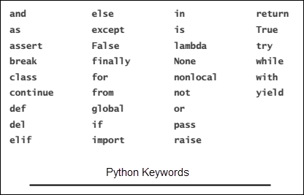
We will learn more about some of the keywords mentioned here as we progress through this course.
The following are some valid and invalid variable names:
home4you - Valid
after_you - Valid
_thatsall - Valid
all10 - Valid
python_101 - Valid
$money - Invalid, variables can't begin with $ character
hello pi - Invalid, variables can't have spaces between them
2001 - Invalid, variables can't begin with a digit
break - Invalid, keyword can't be a variable name

